
Problem
What do you wonder about?


Background Research
What do you already know?


Hypothesis
What do you predict will happen?

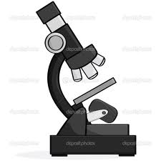
Experiment
What supplies do you need?
What steps will you take?

Results
What happened in your experiment?


Conclusion
What did you learn about your prediction?
What new questions do you have?

